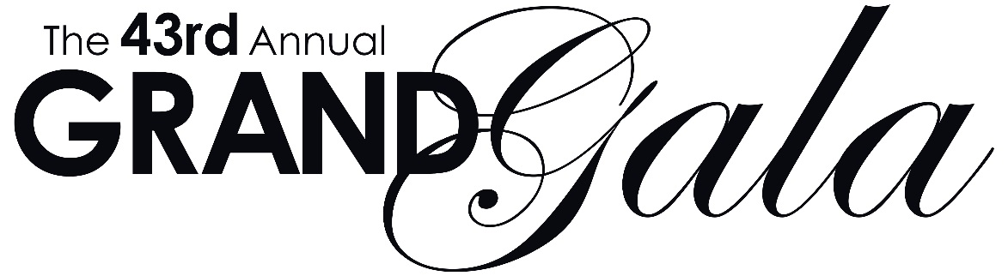

Saturday, December 7, 2019 | 8:00PM | Grand Opera House
followed by the Ultimate After Party at the Hotel du Pont

Gold Ticket – $550 each: Premium Gala seating available in the Parquet, Parquet Circle, and Dress Circle.
Silver Ticket – $350 each: Seating available in the Parquet Circle and Dress Circle.
Bronze Ticket – SOLD OUT Seating available in the Parquet Circle, Dress Circle, and Family Circle.
A special Platinum Package is available at the rate of $1,600 per couple. The package includes two premium tickets to The Grand Gala, access to VIP areas, one overnight stay and valet parking at the Hotel du Pont on the night of the Gala, and Sunday Brunch for two at The Hotel du Pont’s legendary Green Room (reservations required).

The estimated fair market value of each ticket is $220. The balance of your ticket purchase to The Grand Gala is considered a donation to support the vital arts education programs at The Grand and is tax-deductible as allowed by current tax law.

Please note: Acknowledgement of receipt of your order will be immediate.
Your tickets and tax receipt letters will be mailed after November 22, 2019.
Because of the fundraising nature of the event, ticket sales are refundable only for donation credit.

Ticket Level and Quantity: Gold ($550) _____ (# of tickets) Silver ($350) _____ (# of tickets) Bronze ($250) SOLD OUT

Platinum Package _______ (# of packages)

Seating Area Preference: Parquet Parquet Circle Dress Circle Family Circle
Although seating preferences are not guaranteed, The Grand will make every effort to accommodate your request.

Total Ticket Purchase $__________

Contact and Payment Information

Name_______________________________________________________________________________________________________________
(As you would like it to appear in the Grand Gala Program Book. Listing will be alphabetical for orders received by October 25, 2019.)

Address _____________________________________________________________________________________________________________

City __________________________________________________ ST ______ ZIP __________________________________________________

Phone ___________________________________ E-Mail_____________________________________________________________________
Confirmation will be sent to the e-mail address you have provided. Please check this box if you would rather receive a confirmation in the mail.

My check made payable to Grand Opera House is enclosed Credit Card Payment

Card Number _______________________________________________________________________________________________________

Expiration _____/_____ Security Code ________ Cardholder Signature __________________________________________________

For more information, or to purchase tickets, please contact Kate Baker Frawley at
302-658-7897 x3204 or KBFrawley@grandopera.org.

